**PRACTICAL - 2**

**Write programs using the following system calls of UNIX operating system: fork, exec, getpid, exit, wait, stat, readdir, opendir.**

**AIM:**

**Task-02 Write a program to execute following system call fork(), execl(), getpid(), exit(), wait() for a process.**

**Program:**

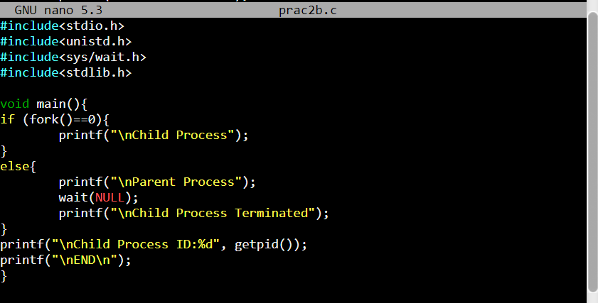

**Output:**

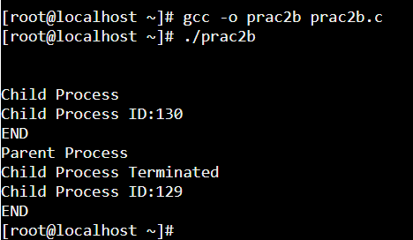

**Conclusion:**

In this practical we have learnt about fork(), execl(), getpid(), exit(), wait() system calls.